LTLMoP Installation Guide – Windows

This guide is meant to provide step-by-step instructions for installing LTLMoP on a Windows computer, including the capability to run simulations in the ODE-based Simulator (included in LTLMoP). The guide was written for a Windows 7 64-bit OS, but should be adaptable to other versions of Windows as well.

A copy of the general LTLMoP tutorial can be found [here.](http://ltlmop.googlecode.com/svn/trunk/doc/tutorial.pdf)

1. **Install Python**
   * Download the x86 Windows installer for Python 2.6.6.
     1. [Direct link to Python installer](http://www.python.org/ftp/python/2.6.6/python-2.6.6.msi)
     2. [Python homepage](http://www.python.org/)
   * Run the downloaded msi-file to install Python. It is recommended that you install to the default directory.
   * Add Python to the Windows system path, so that it can be run from the command line, regardless of directory.
     1. Find the directory containing python.exe file (your Python install directory)
     2. Open the Environment Variables dialog:
        1. Right click on My Computer
        2. Select Properties
        3. Choose Advanced System Settings
        4. Click on Environment Variables
     3. Edit the Path variable (under System Variables), and add the directory with python.exe to the end of the variable (remember to use a semicolon to separate it from the preceding directory). 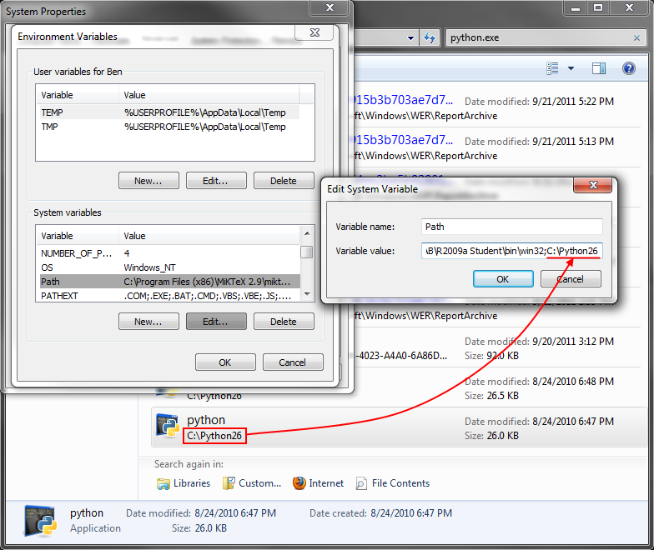
2. **Install wxPython**
   * Download the 32-bit Windows installer for wxPython. Be sure to get the version for Python 2.6.
     1. [Direct link to wxPython installer](http://downloads.sourceforge.net/wxpython/wxPython2.8-win32-unicode-2.8.12.1-py26.exe)
     2. [wxPython homepage](http://www.wxpython.org/index.php)
   * Run the installer. It should automatically detect your installation of Python 2.6.
3. **Install Numpy and Scipy**
   * Download the Numpy installer for Python 2.6.
     1. [Direct link to NumPy installer](http://sourceforge.net/projects/numpy/files/NumPy/1.6.1/numpy-1.6.1-win32-superpack-python2.6.exe/download)
     2. [NumPy homepage](http://numpy.scipy.org/)
   * Run the installer. It should automatically detect your installation of Python 2.6.
   * Download the Scipy installer for Python 2.6.
     1. [Direct link to SciPy installer](http://sourceforge.net/projects/scipy/files/scipy/0.10.0b2/scipy-0.10.0b2-win32-superpack-python2.6.exe/download)
     2. [SciPy homepage](http://www.scipy.org/SciPy)
   * Run the installer. It should automatically detect your installation of Python 2.6.
4. **Install Polygon**
   * Download the Polygon installer for Python 2.6.
     1. [Direct link to Polygon installer](http://download.origo.ethz.ch/polygon/2890/Polygon-2.0.4.win32-py2.6.exe)
     2. [Polygon homepage](http://polygon.origo.ethz.ch/)
   * Run the installer. It should automatically detect your installation of Python 2.6.
5. **Install PyODE**
   * Download the PyODE installer for Python 2.6.
     1. [Direct link to PyODE installer](https://sourceforge.net/projects/pyode/files/pyode/snapshot-2010-03-22/PyODE-snapshot-2010-03-22.win32-py2.6.exe/download)
     2. [PyODE homepage](http://pyode.sourceforge.net/)
   * Run the installer. It should automatically detect your installation of Python 2.6.
6. **Install PyGame**
   * Download PyGame for Python 2.6.
     1. [Direct link to PyGame installer](http://pygame.org/ftp/pygame-1.9.1.win32-py2.6.msi)
     2. [PyGame homepage](http://pygame.org/news.html)
   * Run the installer. It should automatically detect your installation of Python 2.6.
7. **Install PyOpenGL**
   * Download PyOpenGL for 32-bit Windows.
     1. [Direct Link to PyOpenGL](http://pypi.python.org/packages/any/P/PyOpenGL/PyOpenGL-3.0.2a1.win32.exe#md5=55c2f437f20526538e0936341ddc261e)
     2. [PyOpenGL homepage](http://pyopengl.sourceforge.net/)
   * Run the installer. It should automatically detect your installation of Python 2.6.
8. **Install Java JDK**
   * Download the Java JDK installer for Windows x86.
     1. [Direct link to Java JDK installer](http://download.oracle.com/otn-pub/java/jdk/7/jdk-7-windows-i586.exe)
     2. [Java homepage](http://www.oracle.com/technetwork/java/javase/overview/index.html)
   * Add the Java Compiler to the Windows system path, so that it can be run from the command line, regardless of directory.
     1. Find the directory containing javac.exe
     2. Open the Environment Variables dialog:
        1. Right click on My Computer
        2. Select Properties
        3. Choose Advanced System Settings
        4. Click on Environment Variables
     3. Edit the Path variable (under System Variables), and add the directory with javac.exe to the end of the variable (remember to use a semicolon to separate it from the preceding directory).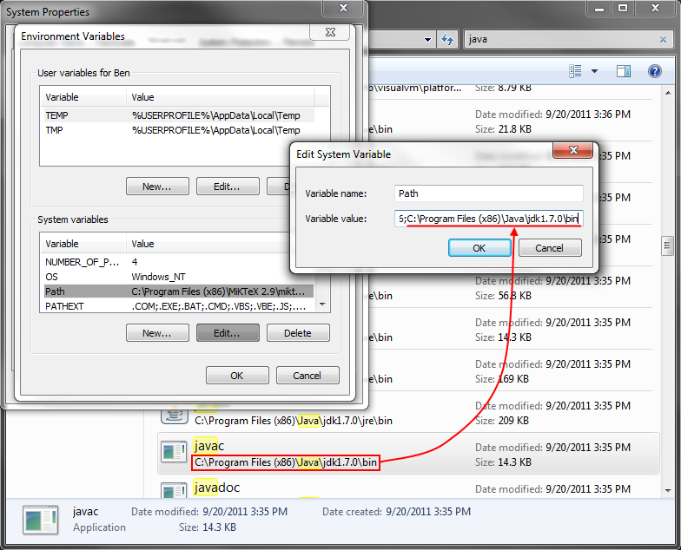
9. **Install LTLMoP**
   * Download an up-to-date copy of the LTLMoP development branch from GitHub.
     1. [Direct link to LTLMoP download](https://github.com/LTLMoP/LTLMoP/zipball/development)
     2. [LTLMoP page on GitHub](https://github.com/LTLMoP/LTLMoP)
   * Extract the contents of the LTLMoP zip-file to the desired install directory.
     1. Do to write permissions, LTLMoP does not behave well when installed to the Program Files directory.
     2. The recommended install directory is “C:\LTLMoP”
10. **Compile jtlv (GROne)**
    * Open a Windows command prompt
    * Change to the GROne directory
      1. cd C:\LTLMoP\src\etc\jtlv\GROne
    * Compile jtlv
      1. javac -sourcepath . -cp ../jtlv-prompt1.4.0.jar *.java 